**IT101-2L**

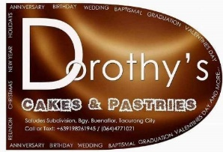**BUSINESS NAME:** Dorothy’s Cakes and Pastries

**Nature of Business:** Home Baking and Catering Services

**Business Process:**

**Ordering System**

- Online through Private messaging (via Messenger)

-Physical (Private home address)

- Middleman ordering (through relatives/associated person/s)

**Product Selection**

-basic products (Choco moist, brownies, chiffon, pastries, etc.)

-semi-customized (selection based on previous customized products)

-customized products (fondant, birthday cakes, layer cakes, wedding cakes, etc.)

**Product Delivery**

-Pick-up (agreed address or private home address)

-delivery (discussed during the ordering period)

**Payment System**

-Cash (upon receiving the product)

-Cashless (debit)

**Business possible issues/inefficiencies:**-no fixed product list.

-loss of profits due to cancellation.

-no dedicated order tracking system

-no ingredients stock tracking system

-no standardized products (customized)

**Goals and objectives**

-create a simple tracking system that inputs the date of order received, delivery date, order type, and order status. An automatic calculation will provide the optimal production time to ensure the product's freshness and quality (no dedicated order tracking system).

**-**develop a system that can calculate the required ingredients for each batch of orders using an existing recipe database. The system should be able to deduct the necessary materials from the available stock and indicate if any additional ingredients need to be purchased. (no ingredients stock tracking system).

-create a database for the product lists, covering the most basic orders and sizes and containing prizes and sample images for it. Will have a function to add customized products for future references (-no fixed product list, -no standardized products (customized))

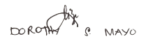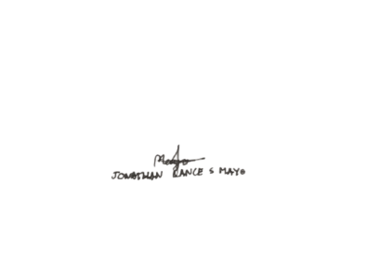Verified by:

Dorothy S. Mayo

**Business Owner**

Jonathan Lance S. Mayo

**Assistant Personnel**